Part A
I
A
B
C
D
E
F
G
Objective : Name and decribe each component
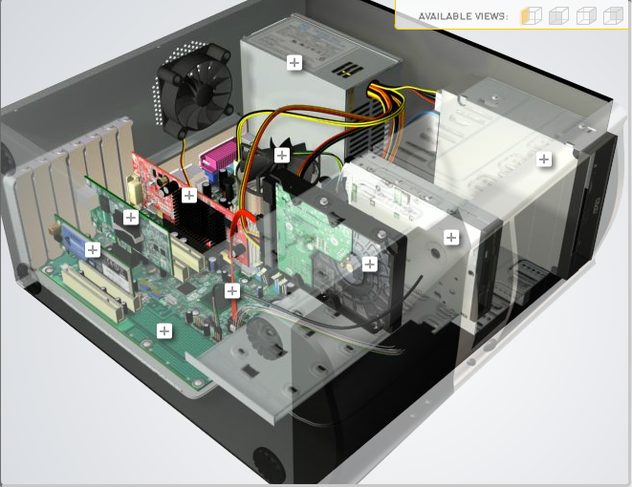
H
Download http://tinyurl.com/CW208-CAG-SIM PC Build Simulator.
Go through steps of building a PC, as you complete the simulation find and describe in detail components A to I. To run simulator first install http://www.swffileplayer.com/ and open RootMovie.swf using SWF player. Alternatively install Macromedia Flashplayer . Ideally use a simulator as listed in class.
Label | Name each component | Description
A | RAM | Super fast memory. Gives applications places to store data on a short term basis.
B | Graphics Card | Renders images and animations
C | Fan | Keeps components/CPU from overheating
D | Power Supply | Supplies power to the pc/components.
E | Hard Disc Drive | Stores all digital content on the computer.
F | CD Drive | Allows use of DVDs and CDs
G | Hard Drive | Stores all permanent data on the computer
H | CPU | Allows computer to interact with with all apps and programs on a computer
I | Motherboard | Connects all hardware to the processor

Part B
Objective
Compare a pre-assembled system and the components that could be assembled to build a comparable system. After completing this practical, you should be able to:
- Identify the components of a pre-assembled system
- Locate prices for components needed to assemble a comparable system
- Compare the cost of a pre-assembled system and a self-assembled system.
If you can’t find exact match for components, find the closest possible substitute. Use the Internet and available computer-related publications as your sources for information. Examples of websites for computer parts www.komplett.ie, www.dell.ie, www.custompc.ie www.amazon.de
MAKE SURE TO INCLUDE VALID LINKS TO WEB REFERENCES
 | Pre-Assembled Computer Package | Computer Package  Components
CPU | - Intel® Core™ i7-10700K | Intel Core i5-9400F 9th Gen Processor
Storage / Memory
 | - 2TB SEAGATE BARRACUDA HDD | ADATA XPG Gammix D10 8GB (1x8GB) 3000MHZ DDR4 RAM  Kingston A400 240GB 2.5" SSD Solid State Drive
  RAM
  Hard Drive
  6GB Corsair VENGEANCE 3000MHz
Input/Output
 | Not Included  Not Included  Not Included  Not Included  SUS® ROG STRIX Z590-E GAMING WIFI | Not Included  LOGITECH M185 Wireless Optical Mouse  Fellowes Rotating Monitor Riser Graphite (Platform rotates 45 degrees 14kg capacity) 9145003  Not Included  Not Included
  Keyboard
  Pointing Device
  Monitor
  Speakers
  Network Adapter
Bundled Software  (Including Operating System) | Windows 10 Home | Windows 10
Total Cost | €3220 (inc. VAT) | €500

Part C
Objective
You have been asked by a family friend to assist them with a computer purchase. They’re unfamiliar with technology and the terms used and have presented you with two alternatives machine choices. They would like to be able to write word documents, surf internet and play Minecraft © Mojang and Half-Life © Valve Software. They are considering playing Fortnight but are not sure yet, as it depends on machine cost and if they can extract some money from their Bitcoin wallet.
Compare Personal Computer Option A and B in relation to each of the side headings and recommend a system and any alterations.

 | Personal Computer  Option A | Personal Computer  Option B
CPU | 2.2 GHz Intel Celeron 450 | 3.2 GHz Intel Core i5
Memory
  Cache
  RAM
  Hard Drive
  CD-ROM/DVD
  512 KB Cache
  4 GB RAM
  320 GB Hard Drive
  DVD+/-RW drive
  4 MB Cache
  8 GB RAM
  1 TB Hard Drive
  DVD+/-RW drive
Input/Output
  Keyboard
  Pointing Device
  Screen
  Speakers
  Network Adapter
  USB multifunction keyboard
  USB optical mouse
  20’’ HD flatscreen monitor
  Multimedia Speaker System
  Integrated 10/100/1000 Ethernet
  wireless multifunction keyboard
  wireless optical mouse
  25’’ HD flatscreen monitor
  Dolby Surround Sound Speakers
  Integrated 10/100/1000 Ethernet

Recommendations
Option A is the cheaper option, but due to low RAM may struggle to run the game. Option B is definitely the pricey one, but could run the game very well.

Option B would be good for business related stuff, but due to the number of things that the family friend would like to do, option B would be better suited for them due to the extra storage and higher RAM memory. Its more expensive, but better for the price.

Your Recommend System
Personal Computer
Recommendation
CPU
Memory

RAM

Hard Drive

SSD Drive

Input/Output

Keyboard

Pointing Device

Screen

Speakers

Network Adapter

GPU

Hand up this practical report at the end of session and ensure it has been checked
Student Name | Jake McDonnell | Student Number | C00259849
Date | 27/10/21 | Checked
Group | B

